**Assignment 7.1:**

**Problem statement**

Calculate the number of employees corresponding to each skill from the table ‘employee’ which is loaded in the demo.

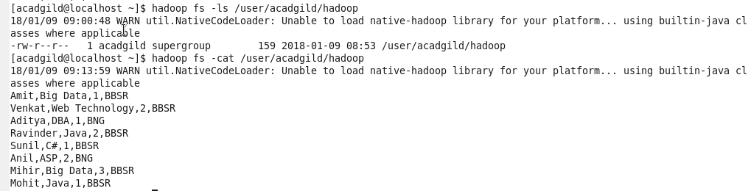



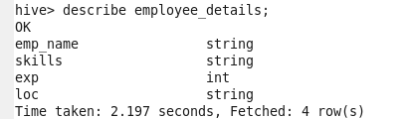

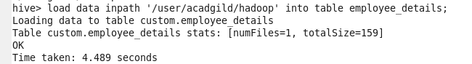

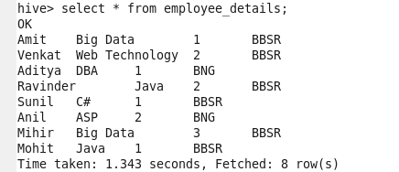



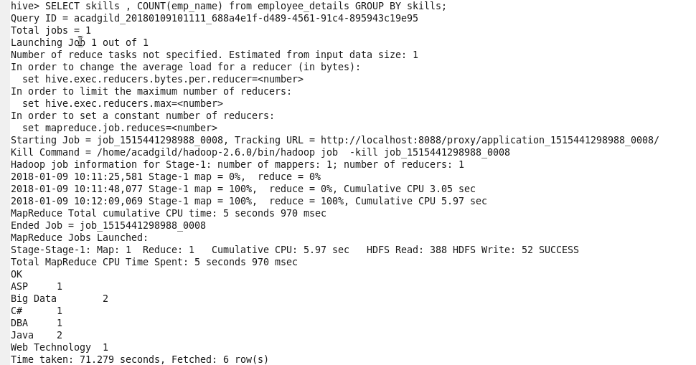

**Output:**

Number of employees corresponding to each skill from the table ‘employee’

